
INSTITUTE OF TECHNOLOGY BLANCHARDSTOWN

BACHELOR OF SCIENCE IN COMPUTING
(Information Technology)

Object Orientation with Design Patterns

CM302

Semester I

Internal Examiner(s): Ms. Orla McMahon

External Examiner(s): Mr John Dunnion
Prof. Gerard Parr

January 2005
Time of examination here

Instructions to candidates:

- Section A: Attempt any five parts.
- Section B: Answer any 3 Questions.
- All questions carry equal marks.

DO NOT TURN OVER THIS PAGE UNTIL YOU ARE TOLD TO DO SO

Section A
Attempt any 5 parts of this question (5 marks each)

Question 1

- Describe briefly what is meant by the term ‘Design Pattern’ and in particular why they are used in software projects.

[5 Marks]

- A common pattern cited in early literature on programming frameworks is the Model-View-Controller (MVC) pattern.
Briefly describe the role of the various participants in the MVC pattern.
[5 Marks]

- What is the intent of the Builder pattern?
Illustrate your answer with a simple example.
[5 Marks]

- When using the Singleton pattern, one approach is to use a static variable and to make the constructor private.
Explain why you would do this in order to implement the Singleton pattern.

[5 Marks]

Question 1 (Contd.)

- Given the following UML diagram, explain briefly the role of each participant in the Decorator pattern.

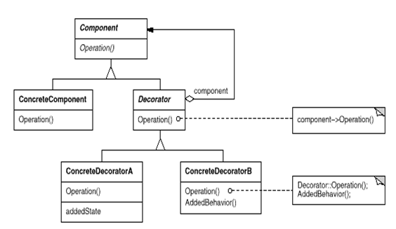

[5 Marks]

- Design patterns can fall into one of three categories.
What are these categories?
Provide a brief description of each category and two examples of design patterns that fall within each category.

[5 Marks]

- Graphical representations of design patterns only capture the end product of the design process.
Why?
List and briefly describe four essential elements that can be used to describe a design pattern.

[5 Marks]

(Total Marks 25)

Section B
Candidates should attempt any 3 of the following questions.

Question 2

Read this case study and answer the questions that follow:

Assume that you are working as a Java Software Designer. You have been requested to update the Garden Planner software system contained in code listing 1. The current system allows a gardener to select a particular garden and a garden area. The plant for that particular area will then be displayed. For example the gardener could select the vegetable garden and then display the plant that is suitable to a shade area. Currently the GUI operates so that the gardener simply selects the garden type, clicks on the appropriate area button (ie central, border or shade) and a suitable plant for the given garden and area appears on the screen.

The following diagram shows the system in operation.

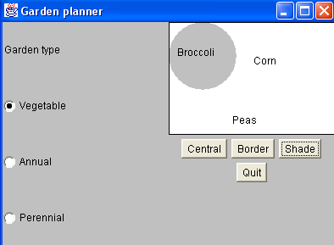

You have been asked to modify the system so that additional gardens can be incorporated into the Garden Planner. The new types of gardens are a Bonsai garden and a Rose garden. In addition to this the garden designer would also like to see the height and watering frequency of each plant that is displayed.

Question 2 (Contd.)

- Draw an accurate UML diagram that illustrates the structure of the Abstract Factory pattern when applied to the updated Garden Planner System.
[5 Marks]

- Taking the above requirements into account, write new classes for the Plant, BonsaiGarden and RoseGarden participants. Assume that the other garden participants have been already modified.
[8 Marks]

- Describe in a step-by-step fashion, how you would edit the current Garden Planner (GUI) (Gardener.java) so that a Rose or Bonsai garden can be selected and in addition to the plant name, the height and watering frequency can also be displayed.

[12 Marks]

(Total Marks 25)

Code Listing 1
Gardener.java
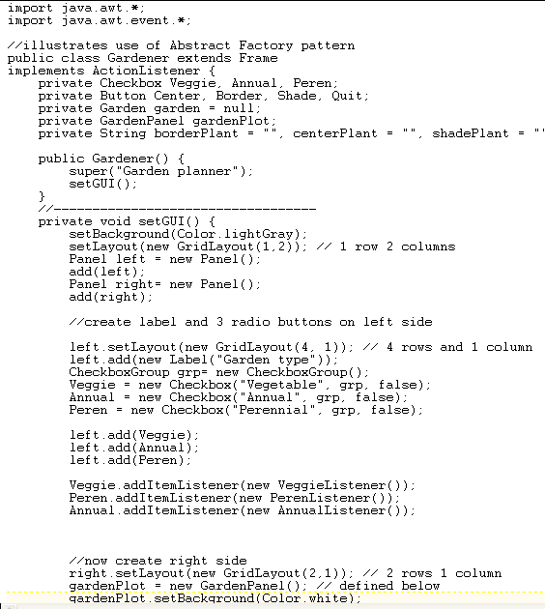
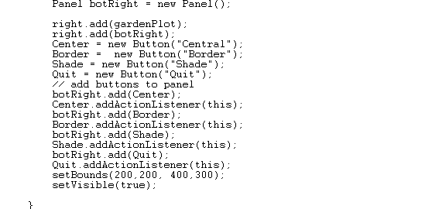

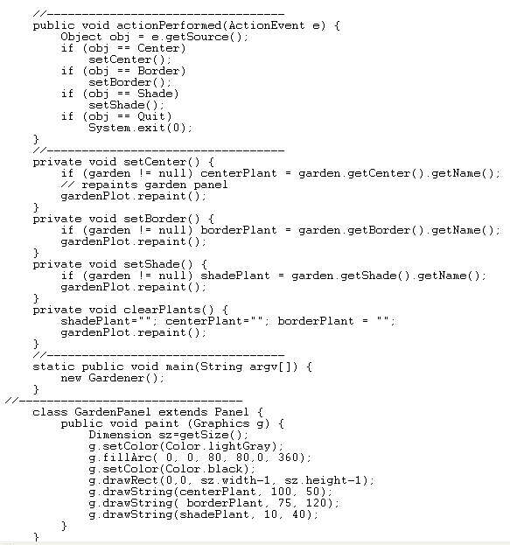
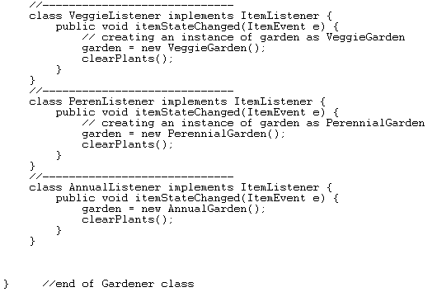

Garden.java

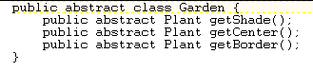

Plant.java

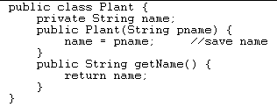

AnnualGarden.java

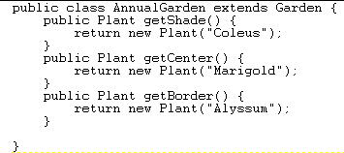
PerennialGarden.java

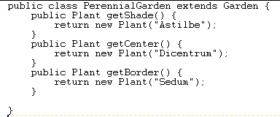

VeggieGarden.java

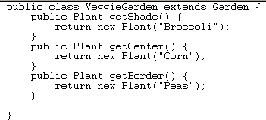

Question 3

- Use an intuitive example to explain the intent of the Composite design pattern.

[6 Marks]

- With the aid of a UML diagram, describe the components of the Composite design pattern

[6 Marks]

- The program code in code listing 2 uses a Flyweight pattern to create folders.
Basically the system draws an icon for each folder with each person’s name displayed under the folder.
Describe in detail the role each class plays in order to implement the Flyweight pattern.
Within each class, provide an explanation of the class methods.

[13 Marks]

(Total Marks 25)

Code Listing 2

FolderFactory.java

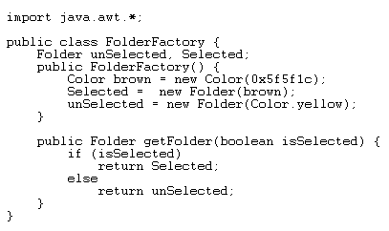

Folder.java

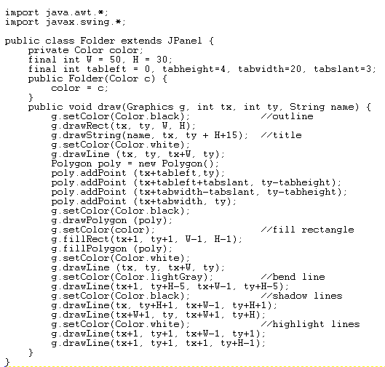

FlyCanvas.java

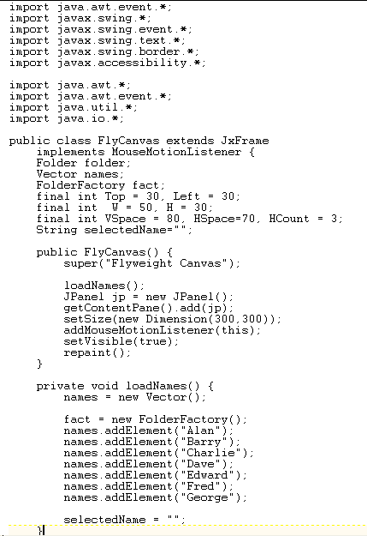
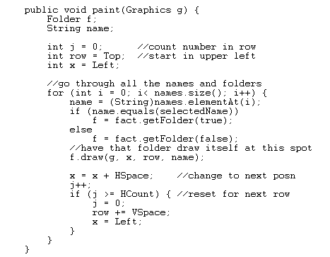
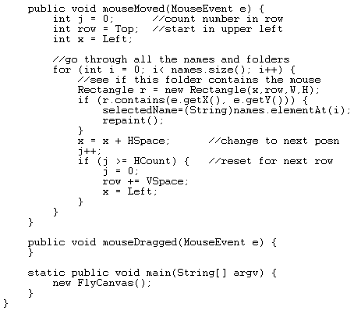
// End of FlyCanvas

Question 4

- Using some simple UML diagrams together with real-world examples, describe the difference between the Factory pattern and the Factory Method pattern.

[8 Marks]

- Explain how the Proxy pattern works.
Illustrate your answer with the aid of three examples.

[6 Marks]
]

- The program given in code listing 3 (on next page) creates a simple user interface that allows the user to select menu items, File|Open and File|Exit,. When the user clicks on a button labelled ‘Blue’, the background colour of the window turns to blue.
As long as there are only a few menu items and buttons this approach works fine, but when there are several menu items and buttons the actionPerformed code can get pretty unwieldy.
Using a simple Command Pattern re-write the appropriate sections of this program so that the conditional block in the actionPerformed code is removed.

[11 Marks]

(Total Marks 25)

Code Listing 3

public class SimpleApp extends Frame implements ActionListener
{
Menu mnuFile;
MenuItem mnuOpen, mnuExit;
Button btnBlue;
Panel p;

public SimpleApp()
{
super("Simple App");

//Create a new menu bar for the frame
MenuBar mbar = new MenuBar();
setMenuBar(mbar);

// Create the menu items and add them to the bar
mnuFile = new Menu("File", true);
mbar.add(mnuFile);
mnuOpen = new MenuItem("Open...");
mnuFile.add(mnuOpen);
mnuExit = new MenuItem("Exit");
mnuFile.add(mnuExit);

// Add an actionlistener for each menu item
// actions will be handled by this class
mnuOpen.addActionListener(this);
mnuExit.addActionListener(this);

// Create a button for the frame
btnBlue = new Button("Blue");

// Create a panel and add the button
p = new Panel();
add(p);
p.add(btnBlue);

// Add an actionlistener for the button
// actions will be handled by this class
btnBlue.addActionListener(this);

setBounds(100,100,200,100);
setVisible(true);
}

// Handle actions from the menu items and button
public void actionPerformed(ActionEvent e)
{
// Determine the source of the action and
// carry out the appropriate action
Object obj = e.getSource();
if(obj == mnuOpen)
fileOpen();
if (obj == mnuExit)
exitClicked();
if (obj == btnBlue)
redClicked();
}

// Called from actionPerformed when exit selected
private void exitClicked()
{
System.exit(0);
}
// Called from actionPerformed when Open selected
private void fileOpen()
{
FileDialog fDlg = new FileDialog(this, "Open a
file",FileDialog.LOAD);
fDlg.show();
}
// Called from actionPerformed when button clicked
private void redClicked()
{
p.setBackground(Color.blue);
}

static public void main(String argv[])
{
new SimpleApp();
}
}

Question 5

- Explain using a simple example how the Facade pattern can simplify the use of a complex system for clients.
[5 Marks]
- What is the intent of the Chain of Responsibility pattern?
Describe two consequences of applying the Chain of Responsibility pattern to a software design problem.
[8 Marks]

- The following example allows the user to display points, lines and squares.
In designing the system, the designer decided to include these shapes in a higher level concept that could be called a ‘displayable shape’.
To accomplish this, the designer created a shape class and then derived from it the classes that represented points, lines and squares (see fig below).
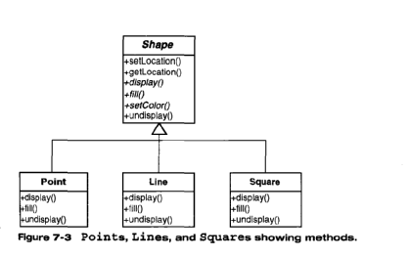
After implementing the above system, the designer was then asked to include a class that could draw circles. This class should also contain all of the required methods such as display(), fill() and undisplay().
The designer then discovered that a colleague had written a circle class that perfomed the exact tasks required. Unfortunately the methods within this class were called displayIt(), fillIt(), undisplayIt().

- Using the Adapter pattern, explain in a step-by-step fashion how you would incorporate the given ‘circle’ class into the above system.
[4 Marks]
- Draw an accurate UML diagram that reflects the updated system.
[4 Marks]
- Provide a Java code fragment for the class ‘circle’ that implements the Adapter pattern.

[4 Marks]

(Total Marks 25)

